Validation Testing

1. I first made sure my density calculation worked and all my entries were used to reach the correct density. After I made sure that it worked, I realized my program would move forward with the calculation even with blank entries, so I made sure to resolve that with different options below.
2. I then wrote a try and except statement with a nested if else to check and make sure that:

A) Convert the user entries for width, length, thickness, and weight to floats

B) Make sure the entries for lot_number, check_date, product_type and intended_density were not left blank by the user.

C) Make sure width, length, thickness, and weight are greater than 0

D) If any of those are left blank to also bring up an error message box.

Displays error when user put letters where numbers should be entered.

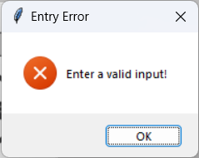

Displays error message box when user leaves entries blank.

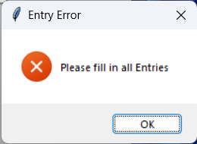

Displays error message box when user enters a negative number.

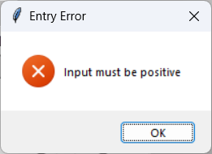

Gives the user the correct density once all entries are filled and measurement are positive.

